DRAFT version of regulatory section for gLAMP review paper
Loop-Mediated Isothermal Amplification Detection of SARS-CoV-2 and Myriad Other Applications
J Biomol Tech. 2021 Sep;32(3):228–275. doi: 10.7171/jbt.21-3203-017
draft by Randy True, paper co-author, FloodLAMP Biotechnologies

LAMP has emerged in the COVID-19 crisis as a core molecular diagnostic technology. Though it still lags far behind PCR in COVID testing capacity and impact, the footprint of LAMP is growing and holds great promise for a variety of different modalities, from point of care and home testing to pooled mass surveillance. Several considerations regarding the regulatory and commercial landscapes of COVID testing, and specifically LAMP, will be discussed below.
Currently, there are 4 primary regulatory pathways for COVID testing in the United States, involving various degrees of oversight: 1) FDA Emergency Use Authorization (EUA);
2) CLIA Lab Developed Test (LDT); 3) Testing as a part of a research study conducted under Institutional Review Board (IRB) approval for human subjects research, and; 4) Surveillance testing where the test results are not returned as "CLIA lab", diagnostic level results, and positives are referred to CLIA diagnostic testing.

FDA Emergency Use Authorizations
Emergency Use Authorizations (EUAs) granted by the FDA comprise the vast majority of tests for COVID-19. EUAs are issued under a streamlined process compared to the non-emergency approvals and clearances of In Vitro Diagnostic (IVD) tests. EUA tests do not require GMP/ISO grade reagents and can use Research Use Only (RUO) reagents and instruments. Individual EUAs for molecular tests for SARS-CoV-2 are classified as either IVDs (211 as of Dec. 26) or LDTs, and IVDs can be test kits sold by a diagnostics manufacturer or may be limited to a specific lab. To help guide the EUA process, the FDA produced templates for EUA submissions and has updated these at various times throughout the pandemic.
To date, there are 10 LAMP IVD EUAs (ref McFarlane chart). The first was granted on April 10 to Atila Biosystems and is a direct (no purification) swab-based fluorescence LAMP test that is read out on an instrument (qPCR machine or custom Atila box). Next was Sherlock Biosciences with a CRISPR assay, also with fluorescence readout (by a plate reader). Color Genomics was the first EUA to use a colorimetric LAMP reaction (NEB 1800/1804 master mix). It includes a commercial lysis/inactivation and commercial bead purification, and it is read using absorbance on a plate reader. Another LAMP EUA of note is from Pro-Lab Diagnostics (technically a proprietary isothermal amplification termed “Omega”), comprising a nasal swab protocol with 2 variations - a 100 µl elution and direct amplification, or a 1 mL elution followed by RNA extraction — with readout on the UK-based company Optigene's GenieHT instrument (also fluorescence based). In addition to monitoring fluorescence intensity during isothermal amplification, the test includes a melting curve analysis of the amplification products, requiring the annealing temperature to fall within a narrow range specific to the target sequence. Pro-Lab reported an impressively low LOD of 125 genome equivalents per flocked swab (using BEI gamma irradiated cell lysate).
The limit of detection (LOD) has been a key driving metric for SARS-CoV-2 tests and the source of much confusion and controversy. Research has shown that the viral load dynamics (Wofle) typically spike over just a few days (Larremore, Mina, Parker), and that the infectiousness threshold for replication competent virus is approximately 1e6 cp/mL (O'Connor), 1,000 cp/µl. The "gold standard" purified RT-PCR test typically has an LOD of a few cp/µl, however less sensitive tests can detect the vast majority of COVID infections that are capable of spreading the virus, especially if used frequently and with less than 24 hour turnaround times.
In September 2020, the FDA released the first round of results of a comparison of LoDs for EUA molecular diagnostic tests. The reference panel standards were shipped to EUA test developers starting in May. The results showed that the EUA tests varied in LOD by 4 orders of magnitude, with the LODs of many flagship tests being 20 to 50 fold higher than their self-reported LODs published in their EUAs (see: FDA SARS-CoV-2 Reference Panel Comparative Data - compiled by M. McFarlane and the source data from the FDA at SARS-CoV-2 Reference Panel Comparative Data). Three rounds of reference panel LOD results have been released, yet the authors are not aware of any explanation for the large discrepancy in LOD. Currently the reference panel materials( consisting of 1 known concentration heat-inactivated virus stock and 4 blinded controls) are only available to EUA holders. Access to these materials for EUA submissions would improve objectivity and potentially speed the validation process.

CLIA and Lab Developed Tests (LDTs)
"The Clinical Laboratory Improvement Amendments of 1988 (CLIA) regulations include federal standards applicable to all U.S. facilities or sites that test human specimens for health assessment or to diagnose, prevent, or treat disease" [CDC]. The FDA’s relationship to regulating LDTs (LDT CLIA FAQ), both for non-emergency declaration tests and EUAs, is complex and evolving. Outside of an emergency declaration, CLIA labs can develop LDTs (aka "home brew" tests) that are limited to their specific lab and require more limited analytical validation data sets. Once the COVID-19 Emergency Declaration by HHS went into effect, CLIA labs were required to submit EUA LDTs. Liability protection (under the PREP Act) and reimbursement (under the FFCRA) both require an EUA. In early October, the FDA announced it would no longer review LDT EUA submissions, creating "new uncertainty for laboratories amidst an already tumultuous environment" [360Dx Bonislawski 10-12-2020]. On November 16, 2020, this decision was reversed by HHS, which directed the FDA to resume review of LDT EUAs - though it appears (as of December 26 2020) that no further LDT EUAs have been granted authorization.
The FDA is providing flexibility to certain labs certified under CLIA to run high-complexity tests during the COVID-19 emergency. The FDA is providing flexibility for labs that develop and perform their own coronavirus tests in which each lab validates their test, notifies FDA, and submits the validation data to the FDA within a certain timeframe as part of an EUA request. While many labs purchased commercial tests under an existing EUA, other labs developed and validated their own tests under this temporary policy.

State Authorization
The FDA is providing flexibility to states who want to authorize labs certified to conduct high-complexity tests in that state to develop and perform coronavirus testing. Under this policy, the state or territory takes responsibility for the safety and accuracy of COVID-19 testing by laboratories in its state/territory, and the lab does not submit an EUA request to the FDA.

Institutional Review Boards (IRBs)
Institutional Review Boards (IRBs) are formally designated groups that review and monitor clinical research involving human subjects. The purpose of the IRB review is to assure, both in advance and by periodic review, that appropriate steps are taken to protect the rights and welfare of humans participating as subjects in the research. To accomplish this purpose, IRBs use a group process to review research protocols and related materials (e.g., informed consent documents) to ensure protection of the rights and welfare of human subjects of research.
When any researcher is planning to gather personal data and samples from research subjects to validate their lab test (e.g., against a gold standard like RT-PCR), they must submit their planned study protocol and consent forms to an IRB at their own institution (if they are part of a university) or via a commercial IRB (http://www.circare.org/info/commercialirb.htm).
Rules governing the function of an IRB reside within two government agencies - the Office for Human Research Protections (OHRP) and the Food and Drug Administration (FDA) - both under the United States Department of Health and Human Services (HHS).

Surveillance and Asymptomatic Testing
While the regulated pathways of COVID-19 testing have received most of the attention and funding, a completely unregulated pathway has opened up after being initially blocked. "Surveillance" testing is primarily used to gain information at a population level rather than an individual level. Surveillance testing may involve random sampling of a certain percentage of a specific population to monitor for increasing or decreasing prevalence and determining the population effect from community interventions such as social distancing. The FDA generally does not regulate surveillance testing. [Wellesley, CMS Surveillance FAQ]
However, in mid May, after the U.S. was already experiencing one of the worst COVID-19 epidemics in the world, the FDA shut down the Gates Foundation's home testing effort in the Seattle area. "The study lacked two kinds of clearance," the FDA said: a federal Emergency Use Authorization (a type of pandemic-era green light used to speedily clear tests and medical devices during an emergency) and approval from an outside group of experts tasked with providing ethical oversight for research (an Institutional Review Board). Obtaining either clearance could have allowed the effort to go forward, according to the FDA. [StatNews 5-27-2020, NYT 5-15-2020]
The following exchange occurred in July of 2020 during a webinar entitled "Government-University Dialogue on COVID-19 Surveillance and Testing":
Francis Collins (Director of the NIH): If you’re doing surveillance (as you’ve just described) in a non-CLIA environment and using pooling, and you get a positive pool (I’ve heard of some places that were like, “Well, we still have the original samples, so we could actually quickly run the components of that pool and we can figure out which one of them was actually responsible for the positive, and then we just reach out to that one person and say, ‘You need to get yourself checked out in a CLIA lab.’”) is that allowable?
Seema Verma (Head of CMS which governs CLIA): Yes, that would work because you’re not actually giving results. You’re still making the referral to that particular person to have the actual diagnosis performed in a CLIA lab. So they can repeat that, but just as long as they’re not telling somebody, "Yes, you are positive or negative,” and just saying, “We’re referring you, you need to have a confirmatory test in a CLIA-certified lab.”
[NIH Webinar 7-24-2020]

Further, the following document was published by CMS on Aug 28:
CMS is temporarily exercising enforcement discretion under CLIA for SARS-CoV-2 surveillance testing where patient-specific results are reported (e.g., SARS-CoV-2 surveillance testing that does not utilize a pooling strategy). Specifically, neither CMS nor the State survey agencies on its behalf will cite non-CLIA certified facilities, such as university laboratories, that are performing such testing, provided that the facility does not report actual test results, but only refers an individual with a presumptive positive or inconclusive test result to a CLIA-certified laboratory for further testing.
[CMS - CLIA University Lab Testing 8-28-2020]

In November the FDA stated the following:
When you refer to public health — if it’s totally a surveillance program where individual results are not returned to patients in a CLIA testing manner, but [instead] groups of people are referred to CLIA testing — surveillance testing as defined by the CDC, CMS, FDA websites is not something the FDA is regulating. When it comes to asymptomatic screening, when you want to return a CLIA lab result to an individual patient….That we do regulate.
[FDA Town Hall 11-18-2020]

Several universities and companies describe their testing programs using the term "surveillance". However, because surveillance testing is not formally regulated in the U.S., it is difficult to estimate the extent of testing being performed under this pathway.

While the rollout of vaccines is underway, U.S COVID-19 testing is projected to expand significantly early in 2021 [Rockefeller Foundation Report Dec. 16, 2020]. The role that LAMP tests will play in that increase remains to be seen. Continued progress on both the regulatory and commercial fronts will certainly help realize the immense potential of this important molecular detection technology.

The situation as it stands at the end of 2020 and what we see as the most important, underappreciated points that can lead to increased testing.
- Testing can be done by non-CLIA labs, such as university or community labs, so long as any test results that are reported back to individuals are clearly distinguished from clinical diagnostic results. It has been stated clearly by top officials at the regulatory agencies (FDA, CDC, CMS) that this "surveillance" testing falls outside their jurisdiction.
- Within the clinical diagnostics regime, testing of asymptomatic people does not need the EUA to include the asymptomatic "indication." An EUA test authorized for "persons suspected of COVID" can be used "off-label" for asymptomatic testing, while EUAs limited to the symptomatic indication cannot because they are typically lower sensitivity tests.
- Regarding pooling and asymptomatic screening: "if the pooling scheme has not yet been authorized for asymptomatic screening, we do clearly state on the FDA website and we are supported by the CDC and the CMS, you can use the tests off-label as long as there's no specific limitation ... to only symptomatic patients." [FDA Town Hall 12-9-2020]. There
- "Open Source Protocol" EUAs are a new class of EUA and can be understood as generic molecular tests, with associated lower costs, wider availability and supply chain robustness. As of Dec 27, 2020, there is only one open source/open-access EUA – SalivaDirect from the Yale School of Public Health co-developed by Dr. Anne Wyllie and Prof. Nathan Grubaugh. By focusing on scalability and forgoing profit, SalivaDirect is proving successful for both increasing access to testing and lowering test prices.

INCLUDE
- Detectachem authorization for visual readout direct colorimetric, using master mix sourced from NEB
- Optigene and LGC alternatives
- Color (ref stat article) https://www.statnews.com/2020/08/06/better-simpler-faster-covid-19-test/
- FDA Ref Panel and big differences
- LDT vs EUA designation, 360Dx article about reimbursement and liability HHS
- Diff between EUA and 510K, can use RUO components
- 2400 EUA submissions, initially 30 now 60 reviewers
Explicit prioritization (from FAQ) based on impact and overlap with priorities (pooling, at home), but prioritization system is not public and test developers are stuck waiting on EUA submissions with a clear path forward. Unaccountability and lack of transparency to process.

FDA Links
https://www.fda.gov/medical-devices/coronavirus-disease-2019-covid-19-emergency-use-authorizations-medical-devices/vitro-diagnostics-euas (all IVD EUAs together 311 12/26)
https://www.fda.gov/emergency-preparedness-and-response/mcm-legal-regulatory-and-policy-framework/emergency-use-authorization (by category)
https://www.fda.gov/medical-devices/workshops-conferences-medical-devices/virtual-town-hall-series-coronavirus-covid-19-test-development-and-validation-12162020-12162020
Umbrella EUA for Molecular Diagnostic Tests for SARS-CoV-2 for high complexity CLIA labs

McFarlane LAMP EUA Chart

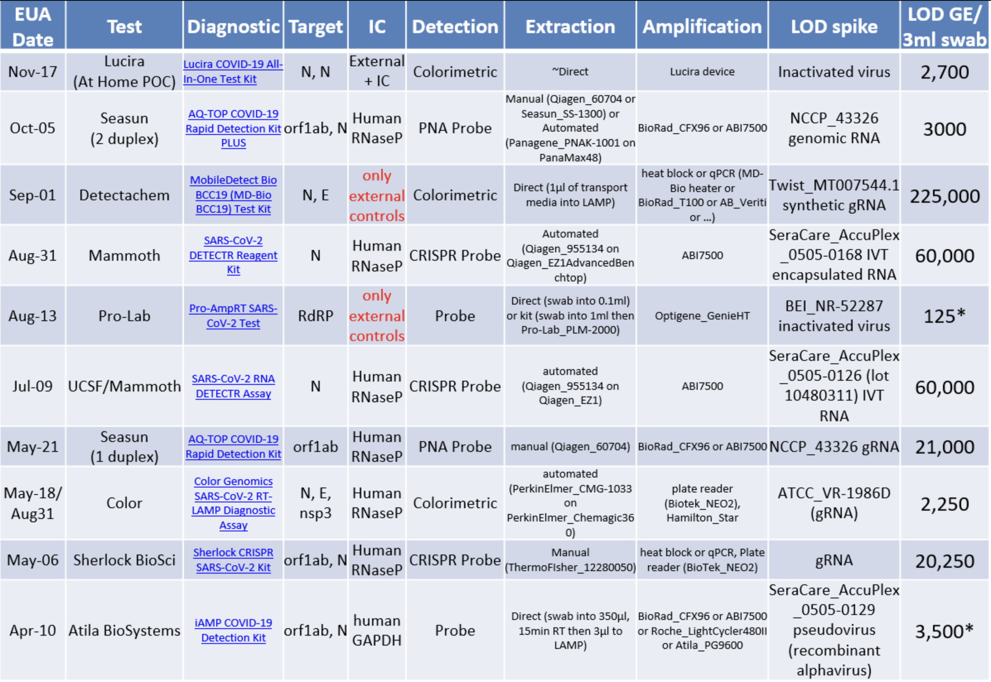
from Matt McFarlane, Twitter @mattmcfar

